Ansible Assignment 1

1. Create 2 AWS Ubuntu instance.
2. Setup Ansible on one instance.

3. Write a playbook to configure another instance with following software.

a. Install git

b. Install maven

c. Install tomcat9

4.Configure hosts inventory file to configure another instance.

5.Execute the playbook.

6. Validate the configuration on another instance with following commands.

a. mvn -version

1. create 2 AWS Ubuntu instance.



1. setup ansible on one instance.

ansible 2

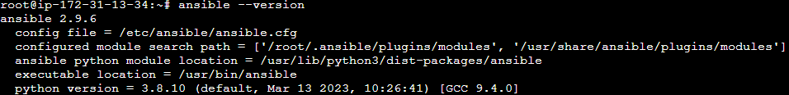

3. Write a playbook to configure another instance with following software.

a. Install git

b. Install maven

c. Install tomcat9

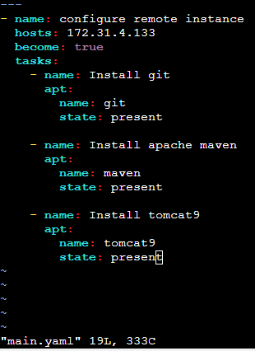

4.Configure hosts inventory file to configure another instance

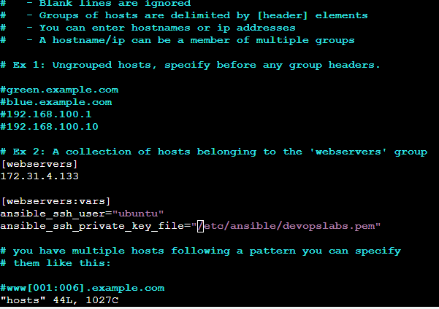

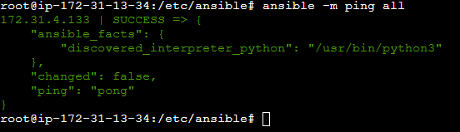

1. excute the playbook.

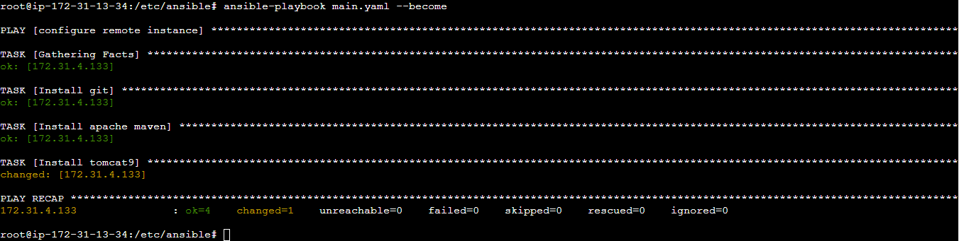

6. Validate the configuration on another instance with following commands.

a. mvn -version

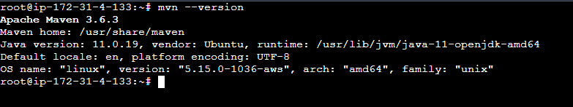



4.Configure hosts inventory file to configure another i